Ex.No:8
Date: Testing of Requirements

Aim:
The aim of this experiment is to analyze the structural complexity of a program and estimate its test coverage using a Control Flow Graph (CFG). This includes identifying nodes, edges, and independent execution paths, and computing Cyclomatic Complexity to determine the minimum number of test cases needed. The experiment also highlights the relationship between program structure and effective software testing

Problem Description
In software testing, it is essential to verify that every part of a program is executed correctly. This experiment focuses on representing a program in the form of a Control Flow Graph, where each statement or group of statements is shown as a node, and the transfer of control is shown using edges.
By studying this graph, we can measure the complexity of the program and identify all possible execution paths. This analysis helps in creating test cases that ensure maximum coverage and improve the chances of detecting errors in the program.

Given Conditions
The program provided includes different types of constructs such as sequential execution, conditional statements (if/else), and loops. It is assumed that the program has one entry point and one exit point. Each logical block is represented as a node, while the connections between them form edges.
The parameters required for analysis are:
- Number of nodes (N)
- Number of edges (E)
- Number of decision (predicate) nodes (P)
These values are used to compute Cyclomatic Complexity and evaluate test coverage.

Methodology
The procedure for this experiment is as follows:
- Examine the program and break it into logical sections.
- Represent each section as a node in the CFG.
- Connect nodes with edges based on the program’s flow of control.
- Count the total number of nodes and edges in the graph.
- Apply the Cyclomatic Complexity formula to measure complexity.
- Determine all independent execution paths.
- Design test cases that cover each independent path to ensure complete testing.

About the Node Diagram (CFG)
The Control Flow Graph (CFG), also called a node diagram, visually represents how a program executes.
- Nodes correspond to statements or blocks of code
- Edges indicate the flow of control between nodes
- Decision nodes represent branching due to conditions or loops
This diagram makes it easier to understand the execution flow and identify all possible paths, which is important for analyzing complexity and designing test cases.

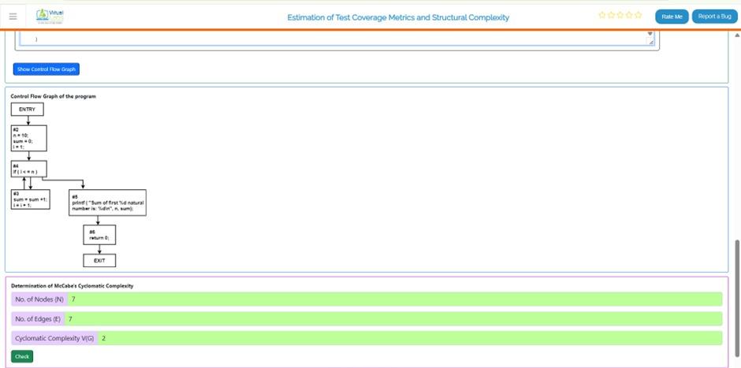
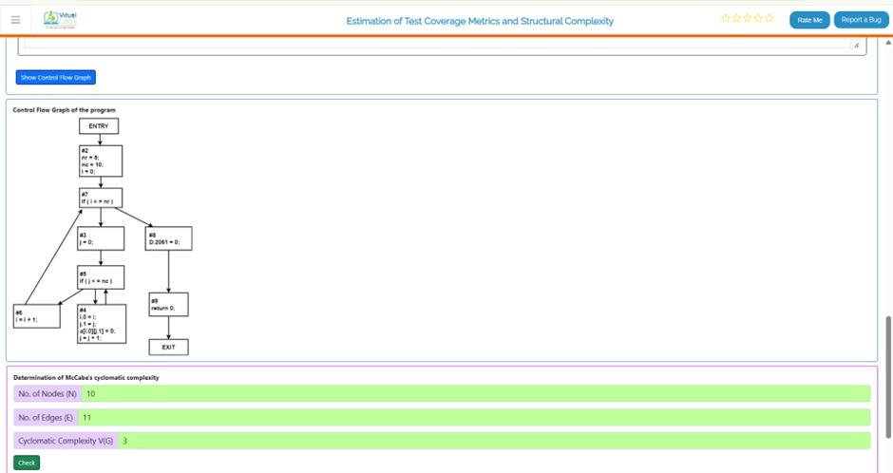
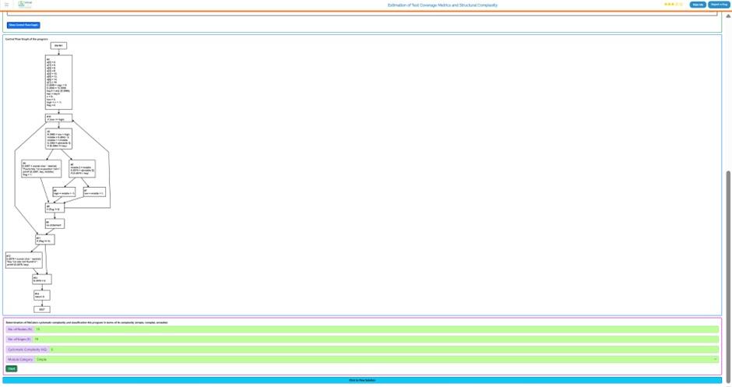

Working of Nodes
In a CFG, nodes represent individual execution steps, and their connections define how the program flows. The complexity of this structure is evaluated using Cyclomatic Complexity.

Formulas Used:
V(G)=E−N+2V(G) = E - N + 2V(G)=E−N+2
Where:
- V(G)V(G)V(G) = Cyclomatic Complexity
- EEE = Number of edges
- NNN = Number of nodes
Another formula is:
V(G)=P+1V(G) = P + 1V(G)=P+1
Where:
- PPP = Number of decision (predicate) nodes
These formulas help in calculating the number of independent paths. Each path represents a distinct route of execution that must be tested to ensure correctness.

Result
After constructing the Control Flow Graph, the values of nodes and edges are determined and used to calculate Cyclomatic Complexity.
For instance:
- Nodes (N) = 10
- Edges (E) = 11
V(G)=11−10+2=3V(G) = 11 - 10 + 2 = 3V(G)=11−10+2=3
This result shows that there are 3 independent execution paths in the program. Hence, a minimum of 3 test cases is required to achieve full path coverage.
The calculated complexity indicates that the program is reasonably simple and can be tested effectively.

Conclusion
The experiment illustrates how Control Flow Graphs can be used to evaluate program complexity and estimate test coverage. By computing Cyclomatic Complexity, we can identify the minimum number of test cases needed for thorough testing.
This technique enhances software quality by ensuring that all execution paths are tested. It also assists developers in understanding the internal structure of programs, minimizing errors, and improving overall design. Therefore, CFG and Cyclomatic Complexity play a crucial role in software testing and quality assurance.

